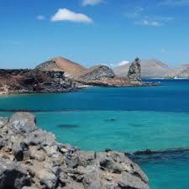**Galapagos Island**

The Galápagos Islands are renowned for their unique and diverse wildlife, inspiring Charles Darwin's theory of evolution.

**History**

The Galápagos Islands, located in the Pacific Ocean, gained historical significance for inspiring Charles Darwin's theory of evolution due to their unique and diverse ecosystems.